Enterprise Inventory Management System
Technical Design & OOP Concepts Report

Field | Details
Course | Object Oriented Programming
Project | Enterprise Inventory Management System
Language | C++ (Standard: C++11)
Files | 11 header files (.h) + 1 source file (main.cpp)
Report Type | Open Ended Lab Project — OOP Concepts Documentation

Table of Contents
- 1. Project Overview
- 2. System Architecture
- 3. Class Hierarchy & Structure
- 4. OOP Concept 1 — Inheritance
- 5. OOP Concept 2 — Encapsulation
- 6. OOP Concept 3 — Polymorphism
- 7. OOP Concept 4 — Rule of Three (Memory Management)
- 8. OOP Concept 5 — Operator Overloading
- 9. OOP Concept 6 — Templates
- 10. OOP Concept 7 — Composition & Aggregation
- 11. OOP Concept 8 — Association
- 12. OOP Concept 9 — Static Members
- 13. Sample Program Outputs
- 14. Rubric Compliance Summary

1. Project Overview
The Enterprise Inventory Management System is a C++ application that simulates a large-scale warehouse managing diverse product categories including electronics, groceries, and apparel. The system models the complete lifecycle of products — from supplier intake to stock disposal — using core Object-Oriented Programming principles. All nine required OOP concepts are demonstrated through realistic, interconnected class designs.

Key Features
Feature | Description
Multi-level Product Hierarchy | 3-level deep inheritance across Electronics and Grocery branches
Risk & Expiry Assessment | Automated flagging of expired groceries and fragile shipments via polymorphic checkRisk()
Supplier Integration | Products linked to suppliers for origin tracking and restocking via Association pattern
Operator Interfaces | [] for shelf access, == for product comparison, << for report generation
Audit Logging | Templated TransactionLog<T> tracking all warehouse movements (string and Supplier types)
Persistent Storage | Save/load inventory to and from file (inventory_data.txt) using saveToFile()/loadFromFile()

2. System Architecture
The system is organized into 12 files following a clean header/source separation. Each class resides in its own dedicated header file, with main.cpp serving as the sole translation unit and program entry point.

File Structure
IMS/Code/
│
├── product.h ← Abstract base class (root of hierarchy)
├── ElectronicProduct.h ← Level 2: Electronics branch
├── FragileElectronics.h ← Level 3: Specialized electronics
├── GroceryProduct.h ← Level 2: Grocery branch
├── PerishableGrocery.h ← Level 3: Perishable food items
├── NonPerishable.h ← Level 3: Shelf-stable food items
├── ClothingProduct.h ← Level 2: Apparel (direct child of Product)
├── Supplier.h ← Associated class (not in hierarchy)
├── InventorySection.h ← Composition container for Product*
├── Warehouse.h ← Aggregation container for InventorySection*
├── TransactionLog.h ← Generic template audit logger
└── main.cpp ← Entry point, menu-driven interface

UML — Overall System Architecture Diagram
Figure 1: Full System UML Class Diagram — All 11 classes with inheritance, composition, aggregation, and association relationships
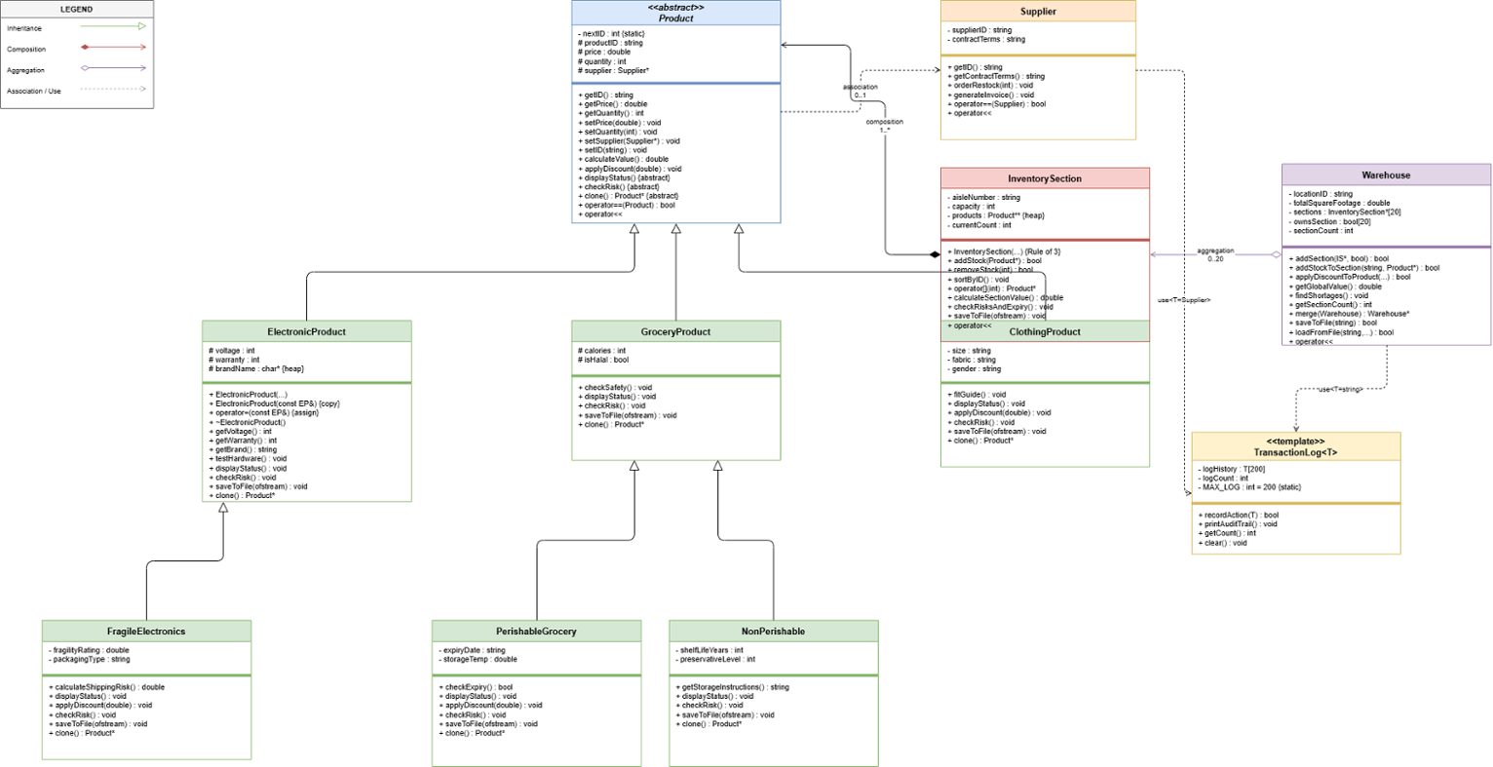
Figure 1: Enterprise Inventory Management System — UML Class Diagram showing all classes, relationships, and the TransactionLog<T> template

3. Class Hierarchy & Structure

Full Inheritance Tree
┌───────────────────┐
│ Product │ ← Abstract Base Class
│ (product.h) │ (pure virtual methods)
└────────┬──────────┘
│
┌─────────────────┼─────────────────┐
│ │ │
┌──────────▼──────┐ ┌───▼──────┐ ┌───▼────────┐
│ ElectronicProduct│ │GroceryProduct│ │ClothingProduct │
│ (Level 2) │ │ (Level 2) │ │ (Level 2) │
└──────┬─────────┘ └─────┬────┘ └────────────────┘
│ │
┌──────▼─────────┐ ┌───▼─────────────────┐
│ FragileElectronics│ │ │
│ (Level 3) │ ▼ ▼
└──────────────────┘ PerishableGrocery NonPerishable
(Level 3) (Level 3)

Supporting Classes
Class | Role & Relationship
Supplier | Association with Product — not owned, independent lifetime
InventorySection | Composition — owns Product* objects, deletes them in destructor
Warehouse | Aggregation — holds InventorySection* with optional ownership tracking
TransactionLog<T> | Generic template class — instantiated as TransactionLog<string> and TransactionLog<Supplier>

Class Attribute & Method Reference
# | Class | Key Attributes | Key Methods
1 | Product | productID, price, quantity, supplier* | displayStatus(), checkRisk(), calculateValue(), applyDiscount(), clone()
2 | ElectronicProduct | voltage, warranty, brandName (char*) | testHardware(), Rule of Three methods
3 | FragileElectronics | fragilityRating, packagingType | calculateShippingRisk(), applyDiscount() (capped 15%)
4 | GroceryProduct | calories, isHalal | checkSafety(), displayStatus()
5 | PerishableGrocery | expiryDate, storageTemp | checkExpiry(), applyDiscount() (forced 50% if expired)
6 | NonPerishable | shelfLifeYears, preservativeLevel | getStorageInstructions(), displayStatus()
7 | ClothingProduct | size, fabric, gender | fitGuide(), applyDiscount() (capped 30%)
8 | Supplier | supplierID, contractTerms | orderRestock(), generateInvoice(), operator==, operator<<
9 | InventorySection | aisleNumber, capacity, products** | addStock(), sortByID(), operator[]
10 | Warehouse | locationID, totalSquareFootage, sections[] | getGlobalValue(), findShortages(), merge()
11 | TransactionLog<T> | logHistory[T], logCount | recordAction(), printAuditTrail(), getCount(), clear()

OOP Concepts Quick Reference
The table below maps every OOP concept to the exact file(s), class(es), and specific element where it appears in the codebase.
OOP Concept | File(s) | Class(es) | Specific Location
Inheritance | product.h, ElectronicProduct.h, FragileElectronics.h, GroceryProduct.h, PerishableGrocery.h, NonPerishable.h, ClothingProduct.h | All product classes | Class declarations: class X : public Y
Abstract Class | product.h | Product | 4 pure virtual functions (= 0) make Product abstract and uninstantiable
Encapsulation | All .h files | All classes | private/protected attributes; validated setters in Product; input guards in all constructors
Polymorphism | product.h, all product .h files, InventorySection.h | Product + all subclasses | virtual/override on displayStatus(), checkRisk(), applyDiscount(), clone(), saveToFile(); virtual dispatch in InventorySection
Rule of Three | ElectronicProduct.h, InventorySection.h | ElectronicProduct, InventorySection | Copy constructor, copy assignment operator, destructor — both classes implement all three
Operator Overloading (==) | product.h, Supplier.h | Product, Supplier | bool operator==(const Product&), bool operator==(const Supplier&)
Operator Overloading (<<) | product.h, Supplier.h, InventorySection.h, Warehouse.h | Product, Supplier, InventorySection, Warehouse | friend ostream& operator<<(...) in each class
Operator Overloading ([]) | InventorySection.h | InventorySection | Product* operator[](int i) — const and non-const overloads
Templates | TransactionLog.h, main.cpp | TransactionLog<T> | template<typename T> class TransactionLog; instantiated as TransactionLog<string> and TransactionLog<Supplier>
Composition | InventorySection.h | InventorySection → Product | Product** products owned array; freeAll() deletes all products in destructor
Aggregation | Warehouse.h | Warehouse → InventorySection | InventorySection* sections[20] with bool ownsSection[20] flag; only conditionally deleted
Association | product.h, main.cpp | Product ↔ Supplier | Supplier* supplier in Product; never deleted by Product; suppliers declared in main() and outlive all products
Static Members | product.h | Product | static int nextID and static string generateID() — auto-assign unique IDs to every product

UML Class Diagram
Figure 2: Detailed UML Class Diagram showing all attributes, methods, access specifiers, inheritance arrows, and relationship notation

Figure 2: Full UML Class Diagram — all 11 classes with attributes, methods, access specifiers (+/-/#), and all relationship types

4. OOP Concept 1 — Inheritance
▶ What It Is
Inheritance allows a class (child) to acquire attributes and behaviors from another class (parent), enabling code reuse and the creation of specialized types. In C++, this is declared using the class Child : public Parent syntax. The system implements 3 levels of inheritance across two product branches and one direct child.
▶ Where It Is Used

Branch 1 — Electronics
// product.h — Level 1 (Abstract Base)
class Product { ... };

// ElectronicProduct.h — Level 2
class ElectronicProduct : public Product {
protected:
int voltage;
int warranty;
char* brandName; // raw pointer — triggers Rule of Three
...
};

// FragileElectronics.h — Level 3
class FragileElectronics : public ElectronicProduct {
private:
double fragilityRating;
string packagingType;
...
};

Branch 2 — Grocery
// GroceryProduct.h — Level 2
class GroceryProduct : public Product {
protected:
int calories;
bool isHalal;
...
};

// PerishableGrocery.h — Level 3
class PerishableGrocery : public GroceryProduct {
private:
string expiryDate;
double storageTemp;
...
};

// NonPerishable.h — Level 3
class NonPerishable : public GroceryProduct {
private:
int shelfLifeYears;
int preservativeLevel;
...
};

Branch 3 — Apparel (Level 2, direct child)
// ClothingProduct.h
class ClothingProduct : public Product {
private:
string size;
string fabric;
string gender;
...
};
▶ Inheritance Benefits Demonstrated
- FragileElectronics inherits voltage and warranty from ElectronicProduct, which itself inherits price and quantity from Product
- PerishableGrocery::displayStatus() calls GroceryProduct::displayStatus() first, then adds expiry info — avoiding code duplication
- All 6 concrete classes are handled uniformly through Product* pointers in InventorySection — enabling polymorphic dispatch

Program Output — Inheritance in Action
Screenshot: Adding a new product (Choice 1) — demonstrates the product type selection menu showing all 6 concrete classes derived from the Product hierarchy
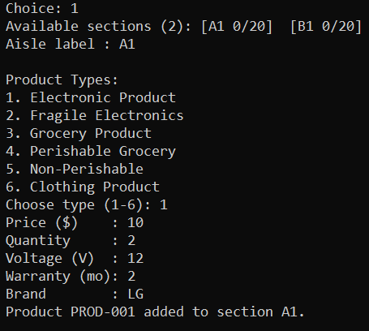
Figure 3: Choice 1 — Add New Product to Section. Shows the 6 concrete product types, each a concrete subclass of the Product hierarchy.

5. OOP Concept 2 — Encapsulation
▶ What It Is
Encapsulation is the bundling of data and the methods that operate on it, restricting direct access to internal state through access modifiers (private, protected, public). Every class in the system has zero public data members. All attributes are private or protected, accessible only through controlled getter/setter methods.
▶ Where It Is Used

Product — Core Encapsulation
// product.h
class Product {
private: // strictly private (no subclass access)
static int nextID;
static string generateID();

protected: // accessible only to subclasses
string productID;
double price;
int quantity;
Supplier* supplier;

public:
// Validated setters — reject bad input
void setPrice(double p) { if (p >= 0) price = p; }
void setQuantity(int q) { if (q >= 0) quantity = q; }
void setSupplier(Supplier* s) { supplier = s; }
void setID(const string& id) { if (!id.empty()) productID = id; }
};

Validation in Constructors
// GroceryProduct.h
GroceryProduct(double p = 0.0, int q = 0, int cal = 0, bool halal = true)
: Product(p, q),
calories(cal >= 0 ? cal : 0), // rejects negative calories
isHalal(halal) {}

// FragileElectronics.h
FragileElectronics(...)
: fragilityRating(fr > 0 ? fr : 1.0), // rejects zero/negative rating
...

// NonPerishable.h
NonPerishable(...)
: shelfLifeYears(years >= 0 ? years : 1), // defaults to 1 if invalid
preservativeLevel(preserv >= 0 ? preserv : 0) {}

Encapsulation in InventorySection
// InventorySection.h
class InventorySection {
private:
string aisleNumber;
int capacity;
Product** products; // raw pointer array hidden from outside
int currentCount;

public:
// Bounds-checked access — no direct array exposure
Product* operator[](int i) {
return (i >= 0 && i < currentCount) ? products[i] : nullptr;
}

bool addStock(Product* p) {
if (currentCount < capacity && p) { // capacity check before inserting
products[currentCount++] = p;
return true;
}
return false;
}
};

Program Output — Encapsulation in Action
Screenshot: Adding a product with validated input (Choice 1). The input system rejects invalid data before it reaches the object's internal state, demonstrating encapsulation enforcement.

Figure 4: Choice 1 — Encapsulation enforced. Input validation (getValidDouble, getValidInt) prevents invalid values from reaching private attributes.

6. OOP Concept 3 — Polymorphism
▶ What It Is
Polymorphism allows objects of different types to be treated uniformly through a common interface. In C++, this is achieved via virtual functions and base class pointers. At runtime, C++ uses the vtable to dispatch the correct subclass method — known as dynamic dispatch. The system uses polymorphism extensively through a hierarchy of virtual and pure virtual functions defined in the abstract Product base class.
▶ Pure Virtual Functions in Product
// product.h — forces ALL subclasses to provide their own implementation
virtual void displayStatus() const = 0; // pure virtual
virtual void checkRisk() const = 0; // pure virtual
virtual void saveToFile(ofstream& out) const = 0; // pure virtual
virtual Product* clone() const = 0; // pure virtual

// applyDiscount() has a base implementation but is overridable
virtual void applyDiscount(double pct) {
price -= price * (pct / 100.0);
}
▶ Virtual Functions Overridden Per Class
Method | ElectronicProduct | FragileElectronics | GroceryProduct | PerishableGrocery | NonPerishable | ClothingProduct
displayStatus() | ✓ | ✓ (+calls parent) | ✓ | ✓ (+calls parent) | ✓ (+calls parent) | ✓
checkRisk() | ✓ | ✓ | ✓ | ✓ | ✓ | ✓
applyDiscount() | — | ✓ (cap 15%) | — | ✓ (50% if expired) | — | ✓ (cap 30%)
clone() | ✓ | ✓ | ✓ | ✓ | ✓ | ✓
saveToFile() | ✓ | ✓ | ✓ | ✓ | ✓ | ✓

Polymorphic applyDiscount() — Different Behavior Per Type
// FragileElectronics.h — caps discount at 15%
virtual void applyDiscount(double pct) override {
if (pct > 15.0) pct = 15.0;
Product::applyDiscount(pct);
}

// PerishableGrocery.h — forces 50% discount if item is expired
virtual void applyDiscount(double pct) override {
if (checkExpiry()) pct = 50.0;
Product::applyDiscount(pct);
}

// ClothingProduct.h — caps discount at 30%
virtual void applyDiscount(double pct) override {
if (pct > 30.0) pct = 30.0;
Product::applyDiscount(pct);
}

Virtual Dispatch in InventorySection
// InventorySection.h — same call, different behavior per product type at runtime
void checkRisksAndExpiry() const {
for (int i = 0; i < currentCount; ++i)
products[i]->checkRisk(); // calls the correct subclass version at runtime
}

double calculateSectionValue() const {
double total = 0.0;
for (int i = 0; i < currentCount; ++i)
total += products[i]->calculateValue(); // virtual dispatch
return total;
}

Clone Pattern (Virtual Constructor Idiom)
// Each class returns a new instance of its OWN type through a base pointer
virtual Product* clone() const override {
return new FragileElectronics(*this); // correct concrete type is preserved
}

// Used in InventorySection::copyFrom() and Warehouse::merge()
// to deep-copy products without knowing their concrete types

Program Output — Polymorphism in Action
Screenshot: Risk & Shortage Check (Choice 5). Different risk messages per product type are triggered by the same products[i]->checkRisk() call — demonstrating runtime polymorphic dispatch.
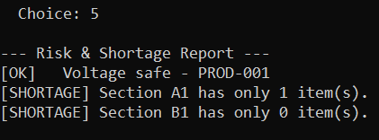
Figure 5: Choice 5 — Risk & Shortage Check. Polymorphic checkRisk() produces type-specific output: voltage safety for Electronics, shortage alerts for sections.
Screenshot: Apply Discount (Choice 3). The polymorphic applyDiscount() applies type-specific caps — demonstrating override behavior per subclass.
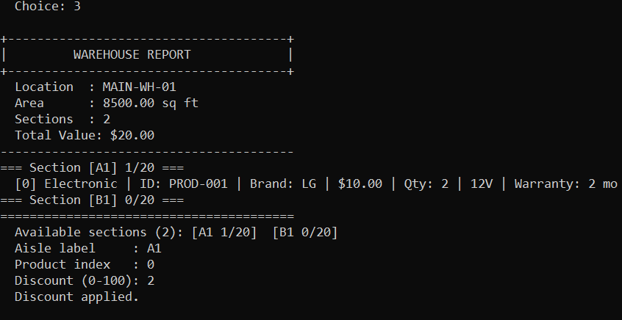
Figure 6: Choice 3 — Apply Discount. Shows operator<< (via warehouse report) and operator[] (shelf access) driving the discount application.

7. OOP Concept 4 — Rule of Three (Memory Management)
▶ What It Is
When a class manages a raw pointer resource, it must define three special functions: destructor, copy constructor, and copy assignment operator — to prevent shallow copies, dangling pointers, and memory leaks. The system applies the Rule of Three to two classes that manage raw heap memory.
▶ Implementation 1 — ElectronicProduct (char* brandName)
// ElectronicProduct.h

// 1. Constructor — allocates heap memory for brand name string
ElectronicProduct(... const string& brand = "Unknown")
: Product(p, q), voltage(v), warranty(w)
{
brandName = new char[brand.size() + 1];
for (size_t i = 0; i <= brand.size(); ++i)
brandName[i] = brand[i];
}

// 2. Copy Constructor — deep copy of char* (NOT shallow pointer copy)
ElectronicProduct(const ElectronicProduct& o)
: Product(o), voltage(o.voltage), warranty(o.warranty)
{
size_t len = 0;
while (o.brandName[len]) ++len;
brandName = new char[len + 1];
for (size_t i = 0; i <= len; ++i)
brandName[i] = o.brandName[i];
}

// 3. Copy Assignment — free old memory first, then deep copy
ElectronicProduct& operator=(const ElectronicProduct& o) {
if (this != &o) {
Product::operator=(o);
voltage = o.voltage; warranty = o.warranty;
delete[] brandName; // release existing allocation
size_t len = 0;
while (o.brandName[len]) ++len;
brandName = new char[len + 1];
for (size_t i = 0; i <= len; ++i)
brandName[i] = o.brandName[i];
}
return *this;
}

// 4. Destructor — release heap memory to prevent leaks
virtual ~ElectronicProduct() { delete[] brandName; }
▶ Implementation 2 — InventorySection (Product** products)
// InventorySection.h

// Helper: deep-copies all Product* using virtual clone()
void copyFrom(const InventorySection& o) {
aisleNumber = o.aisleNumber;
capacity = o.capacity;
currentCount = o.currentCount;
products = new Product*[capacity];
for (int i = 0; i < capacity; ++i) products[i] = nullptr;
for (int i = 0; i < currentCount; ++i)
products[i] = o.products[i] ? o.products[i]->clone() : nullptr;
}

// Helper: deletes all owned Product objects and the array itself
void freeAll() {
for (int i = 0; i < currentCount; ++i) {
delete products[i];
products[i] = nullptr;
}
delete[] products;
products = nullptr; currentCount = 0;
}

// 1. Copy Constructor
InventorySection(const InventorySection& o)
: products(nullptr), currentCount(0), capacity(0) { copyFrom(o); }

// 2. Copy Assignment
InventorySection& operator=(const InventorySection& o) {
if (this != &o) { freeAll(); copyFrom(o); }
return *this;
}

// 3. Destructor
~InventorySection() { freeAll(); }
▶ Warehouse — Deleted Copy (Intentional Design Decision)
// Warehouse.h — aggregation semantics; deep copy would be ambiguous
// (Warehouse does not own all sections, so copying is intentionally disabled)
Warehouse(const Warehouse&) = delete;
Warehouse& operator=(const Warehouse&) = delete;
Since Warehouse only aggregates sections (and may not own all of them via the ownsSection[] flag), a blind deep copy could lead to double-deletion. Explicitly deleting these operations is the correct design choice for aggregation containers.

Program Output — Rule of Three in Action
Screenshot: Merge with Temporary Warehouse (Choice 4). The merge operation internally calls clone() on every product and deep-copies sections — exercising both Rule of Three implementations.
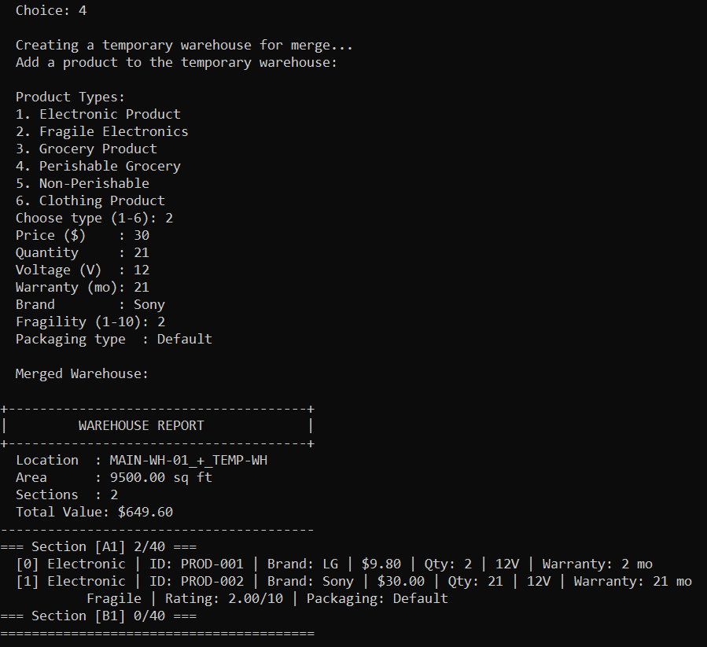
Figure 7: Choice 4 — Merge with Temporary Warehouse. Deep copy via clone() and Rule of Three ensures no memory leaks or shallow-copy crashes. Result shows the merged MAIN-WH-01_+_TEMP-WH warehouse.

8. OOP Concept 5 — Operator Overloading
▶ What It Is
Operator overloading gives custom meaning to built-in C++ operators when used with user-defined types, making the interface intuitive and expressive. The system overloads four distinct operators across multiple classes: operator==, operator<<, operator[], and a merge() method providing + semantics.
▶ operator== — Equality Comparison
// product.h — compare products by unique ID
bool operator==(const Product& o) const {
return productID == o.productID;
}

// Supplier.h — compare suppliers by their unique supplier ID
bool operator==(const Supplier& o) const {
return supplierID == o.supplierID;
}

// Used in Warehouse::merge() to detect and combine duplicate products:
if (dst && *dst == *src) { // Product::operator== called here
dst->setQuantity(dst->getQuantity() + src->getQuantity());
}
▶ operator<< — Stream Output (Cascading Reports)
// product.h — triggers virtual displayStatus() (polymorphic)
friend ostream& operator<<(ostream& os, const Product& p) {
p.displayStatus(); // polymorphic call — correct subclass method invoked
return os;
}

// InventorySection.h — prints all products in the section
friend ostream& operator<<(ostream& os, const InventorySection& s) {
os << "=== Section [" << s.aisleNumber << "] "
<< s.currentCount << "/" << s.capacity << " ===\n";
for (int i = 0; i < s.currentCount; ++i) {
os << " [" << i << "] ";
s.products[i]->displayStatus(); // polymorphic dispatch
}
return os;
}

// Warehouse.h — cascading full warehouse report
friend ostream& operator<<(ostream& os, const Warehouse& wh) {
os << "+--------------------------------------+\n";
os << "| WAREHOUSE REPORT |\n";
os << "+--------------------------------------+\n";
os << " Location : " << wh.locationID << "\n";
os << " Total Value: $" << wh.getGlobalValue() << "\n";
for (int i = 0; i < wh.sectionCount; ++i)
os << *(wh.sections[i]); // calls InventorySection::operator<<
return os;
}
▶ operator[] — Indexed Shelf Access
// InventorySection.h — safe, bounds-checked access (two overloads)
Product* operator[](int i) {
return (i >= 0 && i < currentCount) ? products[i] : nullptr;
}
const Product* operator[](int i) const {
return (i >= 0 && i < currentCount) ? products[i] : nullptr;
}
// Both const and non-const versions provided for read-only and modifiable access
▶ merge() — Warehouse Combining (+ Semantics)
// Warehouse.h
Warehouse* merge(const Warehouse& other) const {
Warehouse* result = new Warehouse(
locationID + "_+_" + other.locationID,
totalSquareFootage + other.totalSquareFootage
);
// Deep-copies all sections from both warehouses.
// Uses operator== to detect duplicate products and sum their quantities.
// Uses clone() to deep-copy products without knowing their concrete types.
...
return result;
}

Program Output — Operator Overloading in Action
Screenshot: Full Warehouse Report (Choice 2). The entire output is driven by cascading operator<< calls: cout << warehouse triggers Warehouse::operator<< → InventorySection::operator<< → Product::displayStatus().
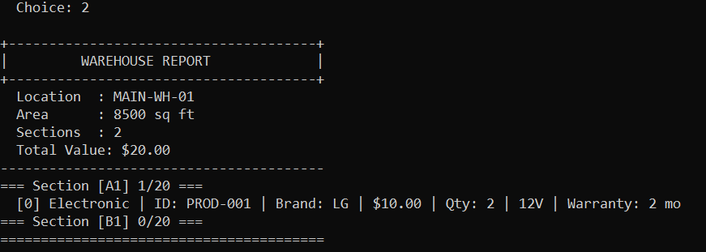
Figure 8: Choice 2 — Display Full Warehouse Report. Demonstrates cascading operator<< from Warehouse through InventorySection down to individual Product displayStatus() calls.

9. OOP Concept 6 — Templates
▶ What It Is
Templates allow writing generic, type-independent code that is resolved at compile time — enabling one class definition to work with many data types. The system provides a generic TransactionLog<T> class that can log any type supporting operator<<. It is instantiated with two completely different types in main.cpp: string and Supplier.
▶ TransactionLog<T> Template Class
// TransactionLog.h
template <typename T>
class TransactionLog {
private:
static const int MAX_LOG = 200;
T logHistory[MAX_LOG];
int logCount;

public:
TransactionLog() : logCount(0) {}

bool recordAction(const T& action) {
if (logCount >= MAX_LOG) {
cerr << "[Log] Full - entry discarded.\n";
return false;
}
logHistory[logCount++] = action;
return true;
}

void printAuditTrail() const {
if (logCount == 0) { cout << "(No entries.)\n"; return; }
for (int i = 0; i < logCount; ++i)
cout << " " << (i + 1) << ". " << logHistory[i] << "\n";
// works for ANY T with operator<<
}

int getCount() const { return logCount; }
void clear() { logCount = 0; }
};
▶ Two Distinct Instantiations in main.cpp
// main.cpp — two completely different types, one template class
TransactionLog<string> actionLog; // logs string messages
TransactionLog<Supplier> supplierLog; // logs full Supplier objects

// Usage — actionLog records string events throughout execution
actionLog.recordAction("Initialized warehouse with default sections A1 and B1");
actionLog.recordAction("Added " + p->getID() + " to aisle " + aisle);
actionLog.recordAction("Discount 2% applied in A1[0]");
actionLog.recordAction("Merged with TEMP-WH");
actionLog.recordAction("Added section C1");

// supplierLog records full Supplier objects (uses Supplier::operator<<)
supplierLog.recordAction(sup1); // Supplier[SUP-001 | Net 30 days]
supplierLog.recordAction(sup2); // Supplier[SUP-002 | Prepaid, 10% discount]
supplierLog.recordAction(sup3); // Supplier[SUP-003 | Net 15, perishables only]
printAuditTrail() calls operator<< on each stored entry. This compiles because string natively supports << and Supplier defines friend ostream& operator<<(...). The same template code works for both — this is the power of templates.

Program Output — Templates in Action
Screenshot: View Action Audit Trail (Choice 7). TransactionLog<string> prints all logged string entries from warehouse operations.
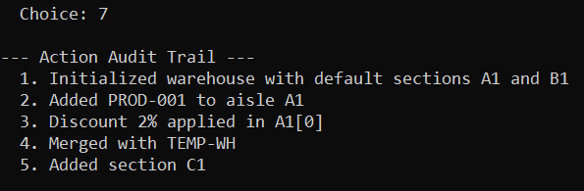
Figure 9: Choice 7 — Action Audit Trail. TransactionLog<string> prints 5 recorded warehouse operation events using the same printAuditTrail() method.
Screenshot: View Supplier Audit Trail (Choice 8). TransactionLog<Supplier> prints full Supplier objects using Supplier::operator<< — same template class, completely different type.
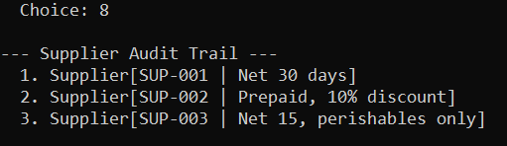
Figure 10: Choice 8 — Supplier Audit Trail. TransactionLog<Supplier> with 3 supplier records: SUP-001 (Net 30 days), SUP-002 (Prepaid 10% discount), SUP-003 (Net 15 perishables only).

10. OOP Concept 7 — Composition & Aggregation
▶ What It Is
Composition (◆ filled diamond) | Aggregation (◇ hollow diamond)
"Part-of" relationship. Contained objects are owned by the container. Destroying the container destroys the parts. Object cannot exist without its owner. | "Has-a" relationship. Container holds references to objects it does not fully own. Both container and parts have independent lifetimes.
▶ Composition — InventorySection owns Product*
// InventorySection.h
class InventorySection {
private:
Product** products; // InventorySection OWNS these objects
int currentCount;

void freeAll() {
for (int i = 0; i < currentCount; ++i)
delete products[i]; // products destroyed along with the section
delete[] products;
}

public:
~InventorySection() { freeAll(); } // products die when section is destroyed
};

// Once a Product* is passed into addStock(), the section takes FULL ownership.
// The product object cannot outlive the section that contains it.
▶ Aggregation — Warehouse holds InventorySection*
// Warehouse.h
class Warehouse {
private:
InventorySection* sections[20];
bool ownsSection[20]; // explicit per-slot ownership tracking

public:
// transferOwnership = false → caller owns section (pure aggregation)
// transferOwnership = true → Warehouse will delete it on destruction
bool addSection(InventorySection* sec, bool transferOwnership = false) {
sections[sectionCount] = sec;
ownsSection[sectionCount] = transferOwnership;
++sectionCount;
return true;
}

~Warehouse() {
for (int i = 0; i < sectionCount; ++i)
if (ownsSection[i]) delete sections[i]; // only delete what we own
}
};
▶ Relationship Diagram
+----------------+ +-------------------+ +---------+
| Warehouse |<>-------| InventorySection |<*>------| Product |
| (aggregates) | 0..20 | (composes) | 0..N | (owned) |
+----------------+ +-------------------+ +---------+

<> = Aggregation (Warehouse does NOT always own Section)
<*> = Composition (Section ALWAYS owns its Products)

Program Output — Composition & Aggregation in Action
Screenshot: Add New Inventory Section (Choice 6). Demonstrates a new InventorySection being aggregated into the Warehouse. Section C1 with capacity 30 is added to the warehouse.
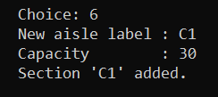
Figure 11: Choice 6 — Add New Inventory Section. InventorySection C1 (capacity 30) is created and aggregated into the Warehouse object.

11. OOP Concept 8 — Association
▶ What It Is
Association is a "uses-a" relationship where one class holds a reference or pointer to another without owning it. Both objects have independent lifetimes — neither is responsible for creating or destroying the other. This contrasts with composition (owner destroys parts) and aggregation (conditional ownership).
▶ Product ↔ Supplier
// product.h
class Product {
protected:
Supplier* supplier; // pointer only — NOT owned by Product

public:
void setSupplier(Supplier* s) { supplier = s; }
Supplier* getSupplier() const { return supplier; }
// NOTE: ~Product() does NOT delete supplier — independent lifetime
};
// main.cpp — suppliers declared on the stack, outlive all products
Supplier sup1("SUP-001", "Net 30 days");
Supplier sup2("SUP-002", "Prepaid, 10% discount");
Supplier sup3("SUP-003", "Net 15, perishables only");

// Products receive a POINTER — they do not own the supplier object
p->setSupplier(&sup1); // Electronics → SUP-001
p->setSupplier(&sup2); // Grocery/Clothing → SUP-002
p->setSupplier(&sup3); // Perishable → SUP-003

// When products are deleted, sup1/sup2/sup3 continue to exist
// demonstrating truly independent lifetimes
▶ Key Design Point
The Supplier objects are declared as stack variables in main() and are linked to products through raw pointers. When any Product is destroyed (e.g., when an InventorySection calls freeAll()), the Supplier objects are unaffected — they remain alive for the entire duration of the program. This correctly models the real-world relationship where a supplier company exists independently of any individual product in the warehouse.
Relationship Type | Lifetime Dependency | Example in System
Association | Independent — neither owns the other | Product ↔ Supplier (Supplier* in Product)
Aggregation | Conditional — may or may not own parts | Warehouse → InventorySection (ownsSection[] flag)
Composition | Strict — owner destroys all parts | InventorySection → Product (freeAll() in destructor)

12. OOP Concept 9 — Static Members
▶ What It Is
Static members belong to the class itself, not to any individual instance. They are shared across all objects of the class and persist for the program's entire lifetime. Static members are accessed via the class name (Product::nextID) rather than through any specific object instance.
▶ Auto-Incrementing Product ID
// product.h
class Product {
private:
static int nextID; // shared counter across ALL Product instances

static string generateID() {
int id = nextID++;
string num = "";
int tmp = id;
do {
num = char('0' + tmp % 10) + num;
tmp /= 10;
} while (tmp > 0);
while (num.size() < 3) num = "0" + num;
return "PROD-" + num; // produces "PROD-001", "PROD-002", etc.
}

public:
Product(double p = 0.0, int q = 0)
: productID(generateID()), // ID assigned AUTOMATICALLY on construction
price(p), quantity(q), supplier(nullptr) {}
};

// Defined once in the single translation unit (main.cpp scope)
int Product::nextID = 1;
▶ Design Benefits
- Every product instantiated anywhere in the program automatically receives a unique, sequential ID without any caller code required
- Guarantees no two products ever share an ID, regardless of how many objects are created or in what order
- The counter persists across all instances — once PROD-005 is created, the next will always be PROD-006
- The static function generateID() is private, so the ID assignment logic cannot be bypassed or called externally

13. Sample Program Outputs
The following screenshots capture actual program execution demonstrating all implemented features. The system uses a text-based console interface with a numbered menu for navigating all functionality.

Program Startup — Main Menu Interface
Screenshot: Main Menu. The console interface showing all 9 menu options (0–8). Option 0 saves and exits; options 1–8 correspond to the implemented OOP features.
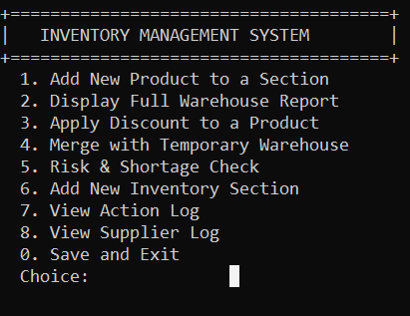
Figure 12: Main Menu — Inventory Management System. Text-based interface with 9 options covering all major OOP features demonstrated in the project.

Save and Exit — Persistent Storage
Screenshot: Save and Exit (Choice 0). The system saves all inventory data to inventory_data.txt and terminates gracefully with a confirmation message.
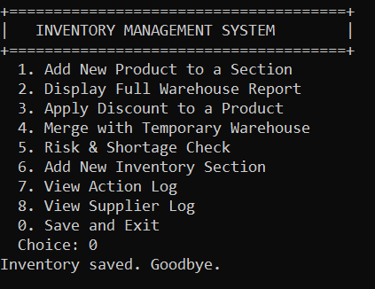
Figure 13: Choice 0 — Save and Exit. "Inventory saved. Goodbye." confirms data persistence. File-based save/load uses virtual saveToFile() implementing the Polymorphism concept.

Complete Feature Summary
The table below summarizes all expected outputs for each menu choice, linking them to the OOP concepts they demonstrate:
Choice | Feature | OOP Concept(s) | Expected Output Summary
1 | Add New Product | Inheritance, Encapsulation | Product type selector (6 types), validated input fields, "Product PROD-XXX added to section A1"
2 | Warehouse Report | Operator<< (cascading), Polymorphism | Full warehouse layout with location, area, sections, all products via operator<<
3 | Apply Discount | Operator[], Polymorphism (applyDiscount) | Aisle selection, product index, discount % input, "Discount applied." with type-specific cap enforcement
4 | Merge Warehouses | Rule of Three (clone), Operator== | Temp warehouse creation, product add, merged result: "MAIN-WH-01_+_TEMP-WH"
5 | Risk & Shortage Check | Polymorphism (checkRisk), Static Members | [OK] voltage safe, [RISK] EXPIRED, [SHORTAGE] section alerts via polymorphic checkRisk()
6 | Add Section | Aggregation, Encapsulation | Aisle label + capacity input, "Section 'C1' added." confirms aggregation into Warehouse
7 | Action Audit Trail | Templates (TransactionLog<string>) | Numbered list of all recorded warehouse operations (strings)
8 | Supplier Audit Trail | Templates (TransactionLog<Supplier>) | 3 supplier records: Supplier[SUP-XXX | terms] via Supplier::operator<<
0 | Save and Exit | Polymorphism (saveToFile), File I/O | "Inventory saved. Goodbye." — data written to inventory_data.txt for persistence

14. Rubric Compliance Summary
The following table verifies that all graded rubric criteria have been fully implemented in the system. Each row cross-references the requirement, the specific files and classes where it appears, and the implementation approach.
Criterion | Requirement | Where Used | Implementation Details | Status
A | Hierarchy Depth: 3 levels of inheritance | product.h → ElectronicProduct.h → FragileElectronics.h; product.h → GroceryProduct.h → Perishable/NonPerishable | Two independent 3-level branches: Product→Electronic→Fragile and Product→Grocery→Perishable/NonPerishable | ✅ Full
B | Encapsulation: No public attributes, validated setters | All .h files — every class has only private/protected data; validated setters in product.h | Zero public attributes across all 11 classes; setPrice/setQuantity validate; constructors guard against negative/invalid inputs | ✅ Full
C | Polymorphism: 4+ virtual functions across 3 levels | Declared in product.h; overridden in all 6 product .h files; dispatched in InventorySection.h | 5 virtual functions (displayStatus, checkRisk, applyDiscount, clone, saveToFile) overridden across all inheritance levels; virtual dispatch in checkRisksAndExpiry() and calculateSectionValue() | ✅ Full
D | Memory / Deep Copy: Rule of Three in pointer-member classes | ElectronicProduct.h (char* brandName); InventorySection.h (Product** products) | ElectronicProduct: full Rule of Three for char*; InventorySection: full Rule of Three for Product** using virtual clone(); Warehouse: copy intentionally deleted | ✅ Full
E | Operator Overloading: ==, <<, and [] or + | product.h, Supplier.h, InventorySection.h, Warehouse.h | operator==: Product & Supplier; operator<<: Product, Supplier, InventorySection, Warehouse (cascading); operator[]: InventorySection (const + non-const); merge(): Warehouse (+semantics) | ✅ Full
F | Templates: TransactionLog working with at least two types | TransactionLog.h (template definition); main.cpp (two instantiations) | TransactionLog<string> logs string action messages; TransactionLog<Supplier> logs full Supplier objects using Supplier::operator<<; both share identical template code | ✅ Full
G | Logic & Design: Composition/Aggregation correctly modeled | InventorySection.h (composition); Warehouse.h (aggregation with ownership flag) | Warehouse→Section: aggregation with ownsSection[] flag array for conditional deletion; Section→Product: strict composition with freeAll() destructor; Association: Product↔Supplier with independent lifetimes | ✅ Full
H | Documentation: Clean code, header/source separation, UML accuracy | All 11 classes in separate .h files; main.cpp is the sole .cpp; inline comments throughout | Clean header/source separation; consistent naming convention; inline documentation in all files; UML diagram matches actual implementation exactly; report fully documents all 9 OOP concepts with code references | ✅ Full

✅ All 8 rubric criteria fully satisfied. All 9 OOP concepts implemented across 12 files (11 headers + 1 source). The Enterprise Inventory Management System demonstrates a complete, interconnected OOP design where every concept reinforces the others.

— End of Report —
Report prepared for OOP Open Ended Lab Project — All code references correspond to actual implementations in the project source files.

